

**2018-2019 SPRING SEMESTER**

**EE494 CAPSTONE DESIGN COURSE**

**MERT KAYIŞ - 2030997**

**PROGRESS DURING THE SEMESTER BREAK**

As the whole group;

We started discussions about what kind of adjustments we can do to our design to meet the specifications. Since the critical design report in the previous semester was not the end of the project, it needs to be updated in consideration of the modifications that we do afterwards. In order to develop new ideas, we decided to find alternative solutions separately, and then combine them or choose (the best) one of them to the final application.

As individual;

At the end of the fall semester, we already had all the subsystems as prototype except the shooting mechanism. We needed to find feasible solutions to shoot the ball into the opponent’s goal. Here, I knew that we should adapt the KISS principle to this part of the project. Simple and reliable solution for shooting sub-system is also important. DC motors will be supplied with a certain level of voltage unless the shooting signal comes to the robot from the remote control unit. When the power is interrupted, the spring will relax and hit the ball. The schematic of this design can be seen in Figure 1.

I have started working as candidate engineer in a system test engineering team. In this semester, I will try to integrate my part-time employment experiences into this capstone project. I believe that it will improve our engineering approach especially on technical and formal testing procedures of our robot.

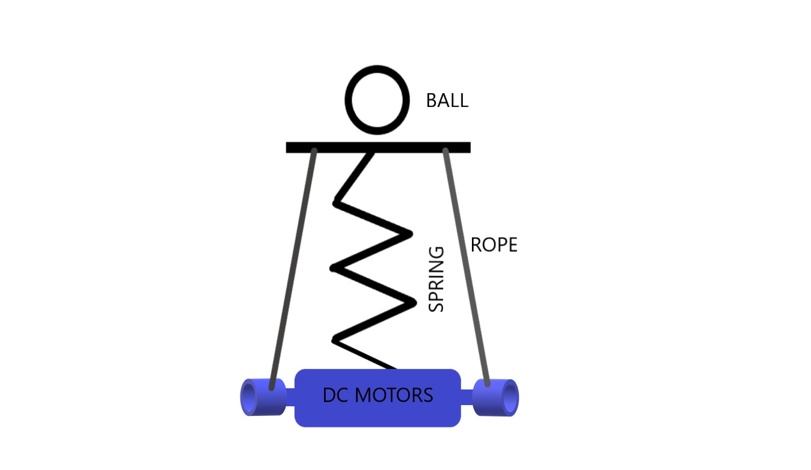

Figure 1: Design schematic of the shooting mechanism including the spring mass system.